**I used a lot of things in this project and I want to tell everything briefly but in detail. In this project, I have used all major programming languages for web sites; html, css, js. And I want to show some photos that I used.**

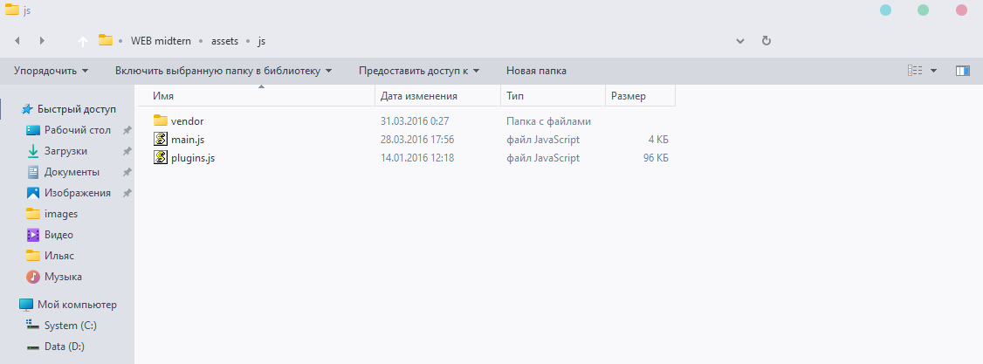

**Here I used js and this js is responsible for all dynamic effects such as animations, popups and dropdown menus.**

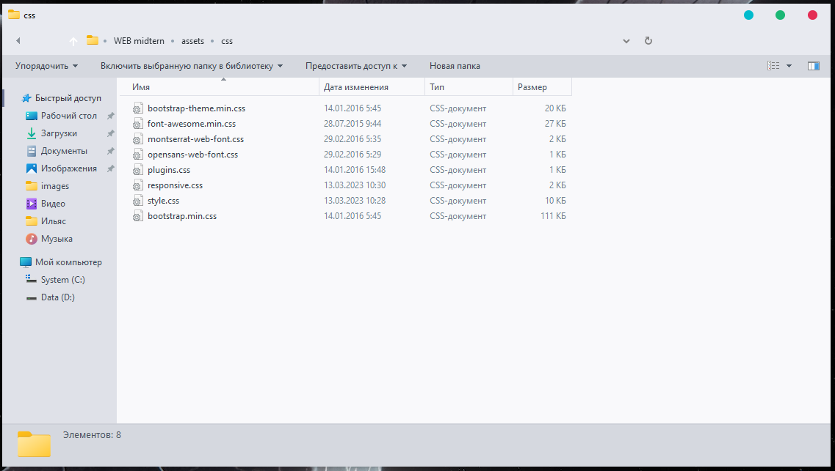

**Here I have used CSS or Cascading Style Sheets to add style and layout to my web page. CSS allows you to change the color, font, and layout of your content. This is important because it will make your website look more professional and easier to read. To use CSS, you need to create a separate file containing all your styles. Then refer to this file from your HTML document.**

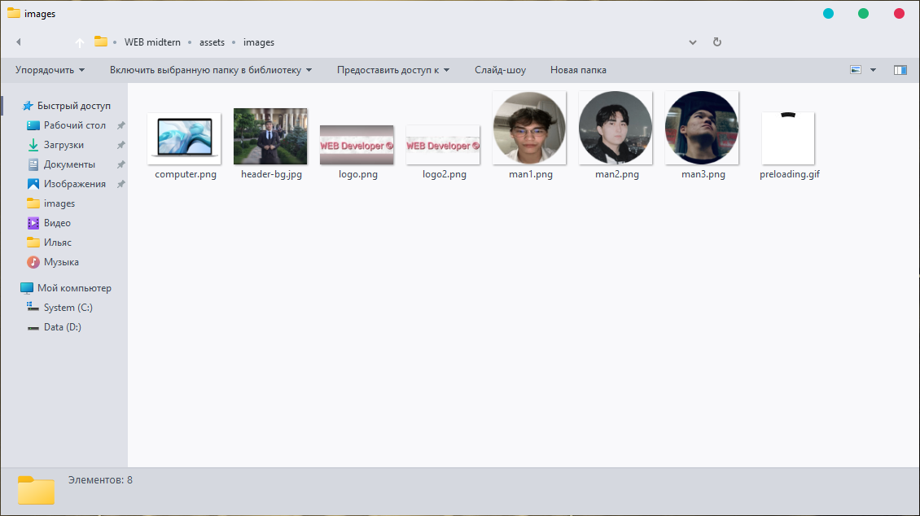

**here I used the paths to the files through the links so that the pictures on my site would be visible.**

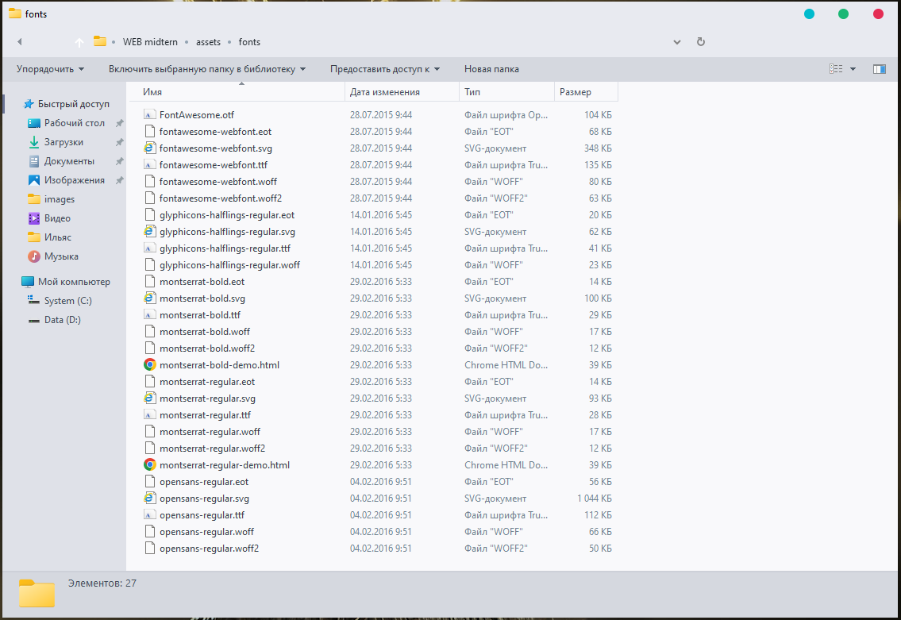

**This fonts**

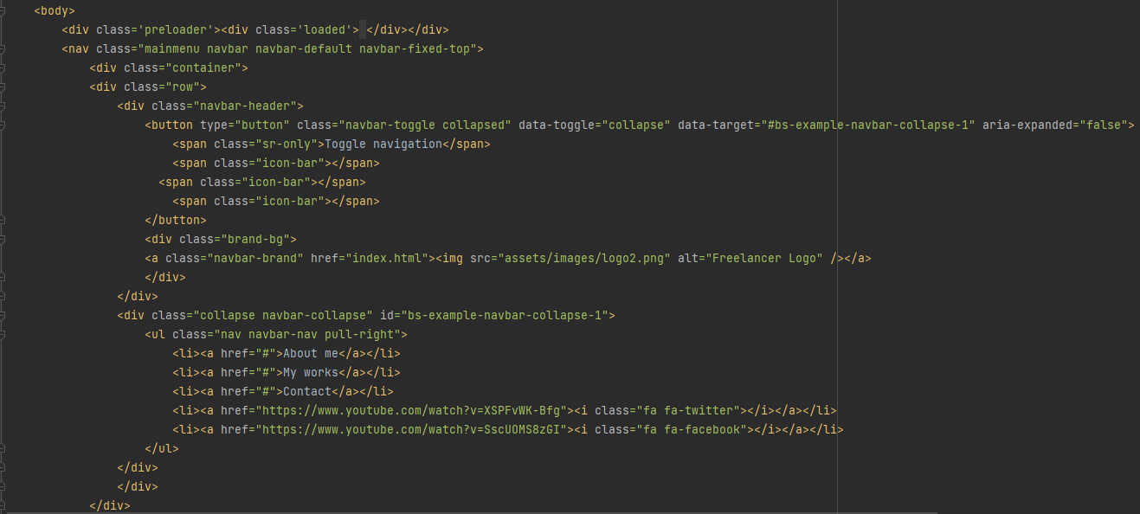

**In this code, I wrote Menu.**

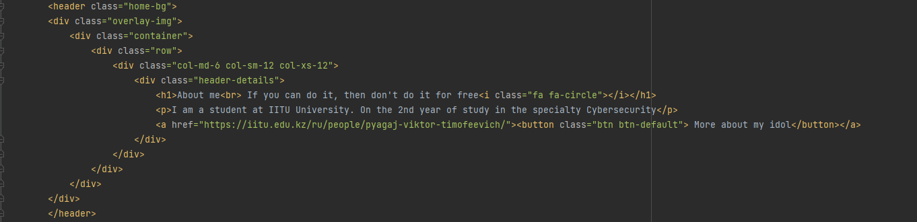

**Its first page in my site.**

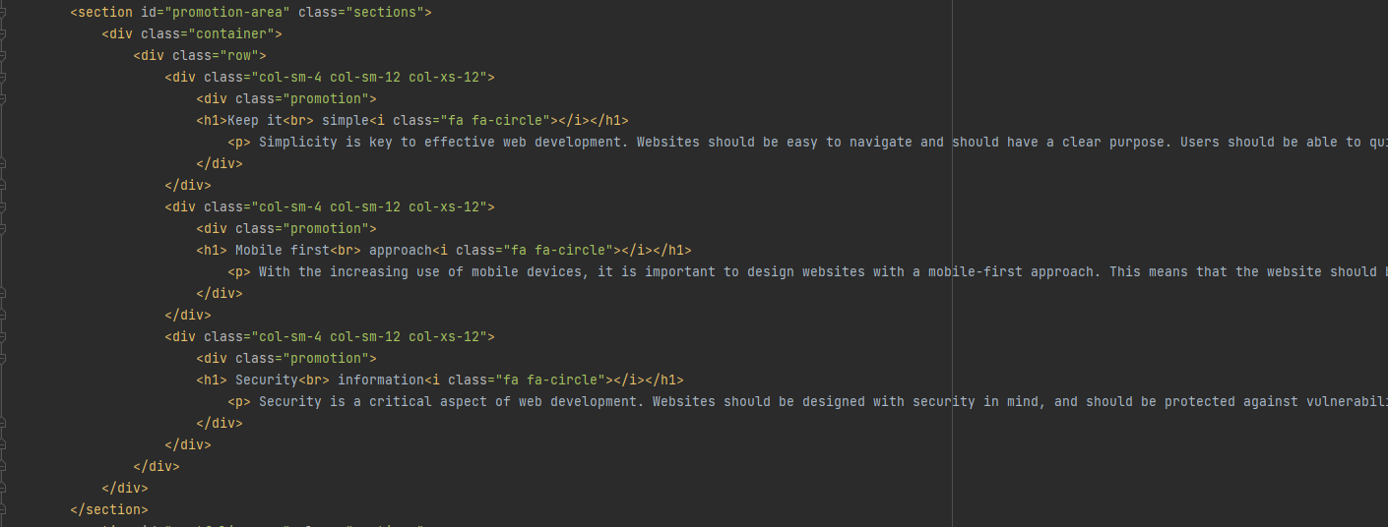

**Its Section 1**

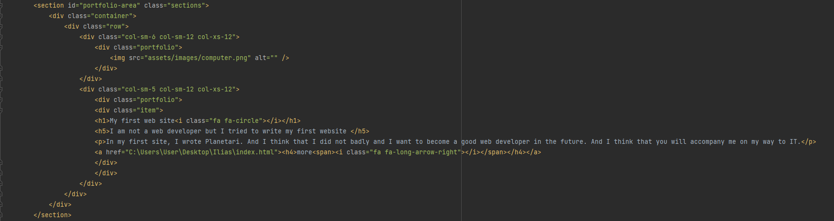

**Section 2**

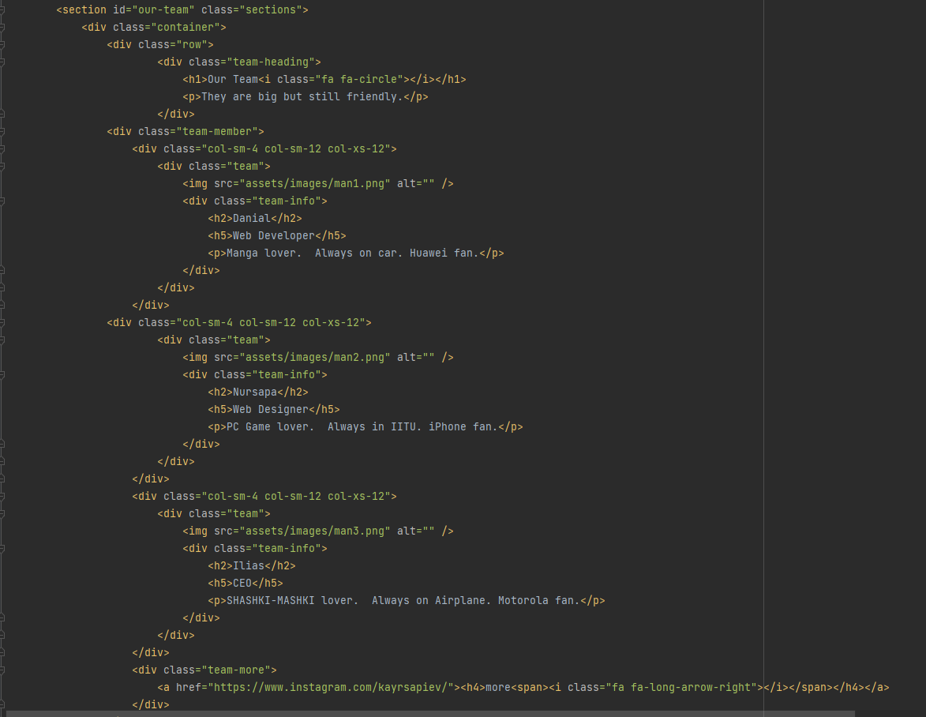

**Section 3**

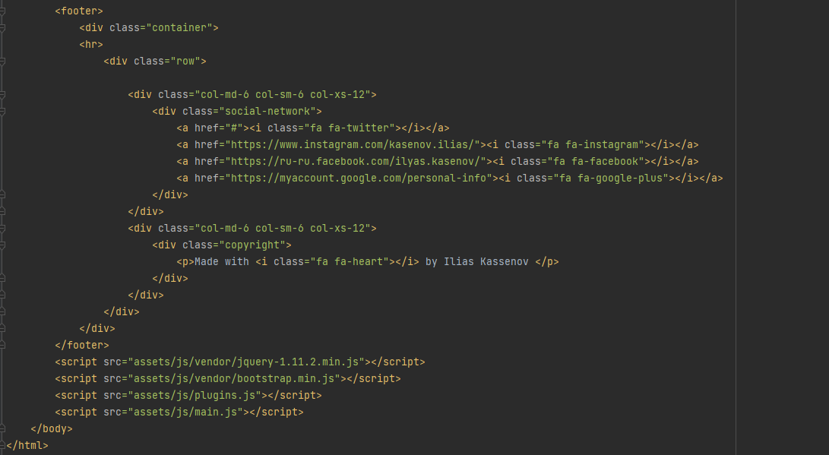

**AND.Footer and End my web site.**